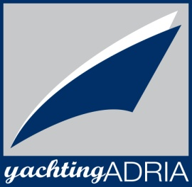
Beneteau Oceanis 48, Miss Ellie
Base | Marina Bar, Montenegro
Year built | 2017
Length | 14.6 m
Berths | 6 + 2
Toilets | 2
Water capacity | 570 l
Fuel capacity | 200 l
Sails | Semi button main sail  with lazy jack, Roll Genoa
Engine | Yanmar 75 HP
Bow thruster | Yes

YachtingAdria
85000 Bar, Montenegro
+382 69 590 657
+381 63 692 287
+381 63 7769 525
office@yachtingadria.com
Yachtingadria
@YachtingAdria
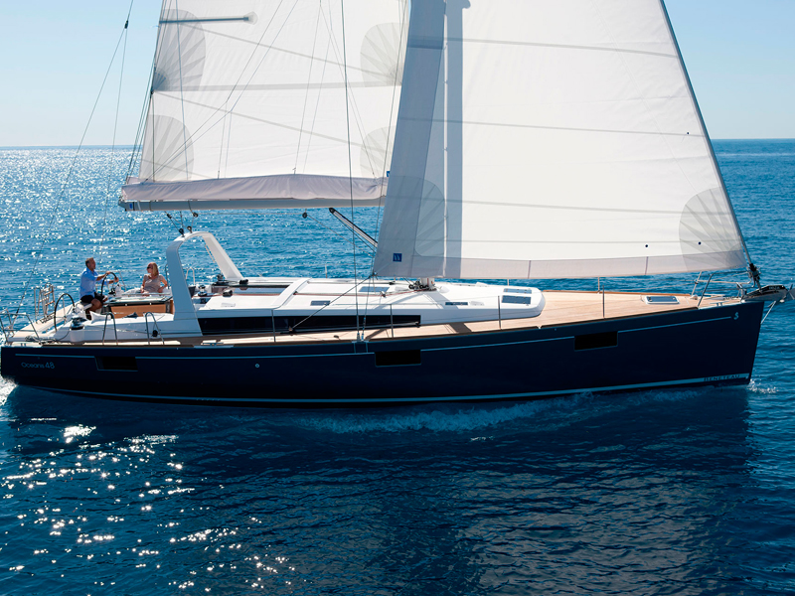

Deck equipment  Bow thruster, electric windlass, bimini top, sprayhood, deck shower, swimming ladder, cockpit table, cockpit speakers | Safety equipment  life jackets, life raft, 1 horseshoe life buoys, radar reflector, distress flare box, first aid kit, fire extinguisher, fog horn, safety harness
Navigational equipment  VHF, Tri data, wind instrument, auto pilot, GPS plotter, sea charts and pilot book, AIS | Other equipment  hydraulic bath platform, refrigerator, stove with oven, LCD/DVD/CD/MP3
