Sun Odyssey 439, Luna
Base | Marina Lazure, Montenegro
Year built | 2013
Length | 13.34 m
Berths | 8
Toilets | 2
Water capacity | 530 l
Fuel capacity | 200 l
Sails | Roll
Engine | Yanmar 54 HP
Bow thruster | Yes

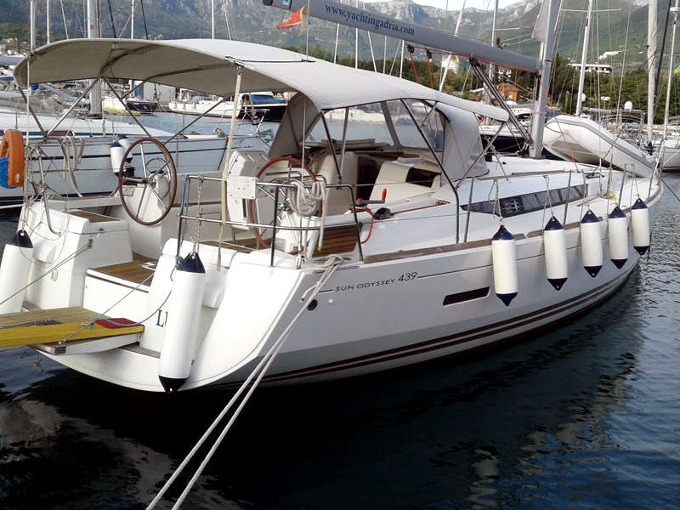

Deck equipment  Bow thruster, electric windlass, bimini top, sprayhood, deck shower, swimming ladder, teak cockpit, cockpit table, cockpit speakers | Safety equipment  life jackets, life raft, 1 horseshoe life buoys, radar reflector, distress flare box, first aid kit, fire extinguisher, fog horn, safety harness
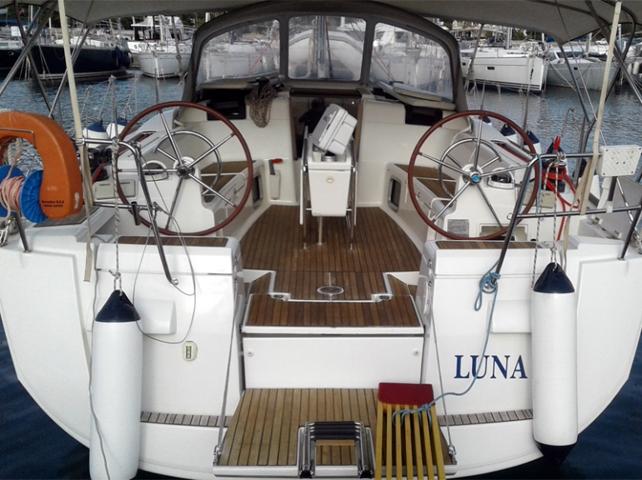  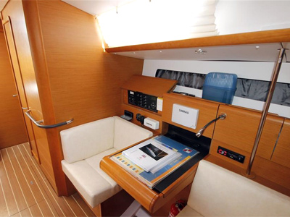  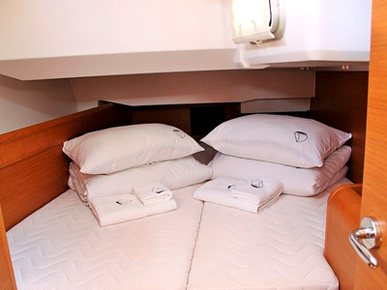  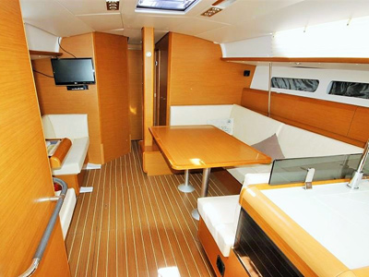  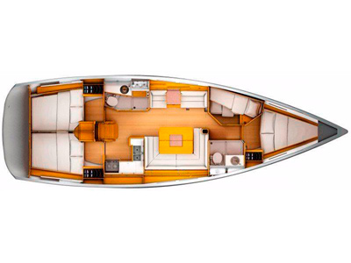  Navigational equipment  VHF, Tri data, auto pilot, GPS plotter, 3G radar, forward scan, sea charts and pilot book | 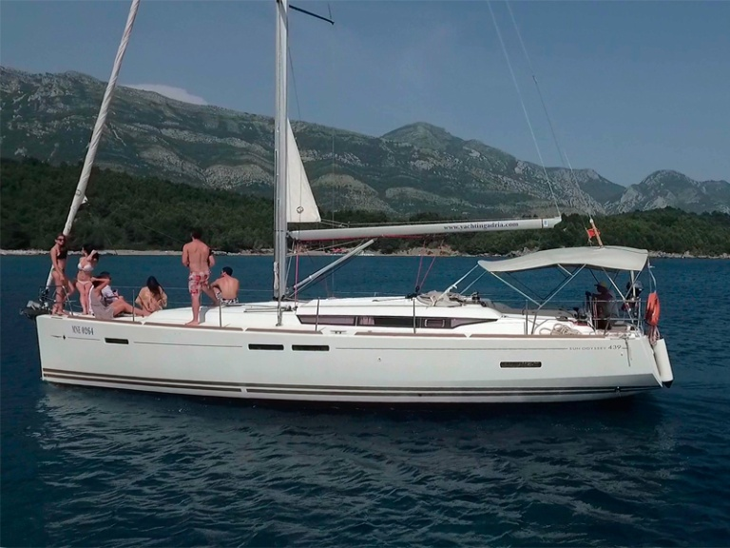  Other equipment  air-conditioning, 4 kw generator, heating, refrigerator, stove with oven, LCD/DVD/CD/MP3/USB

