Sun Odyssey 45.1, Andrea
Base | Marina Lazure, Montenegro
Year built/Refit | 1998/2018
Length | 14.2 m
Berths | 8+1
Toilets | 2
Water capacity | 650 l
Fuel capacity | 210 l
Sails | Roll - Main 2018/Genoa 2014
Engine | Yanmar 65 HP
Bow thruster | No

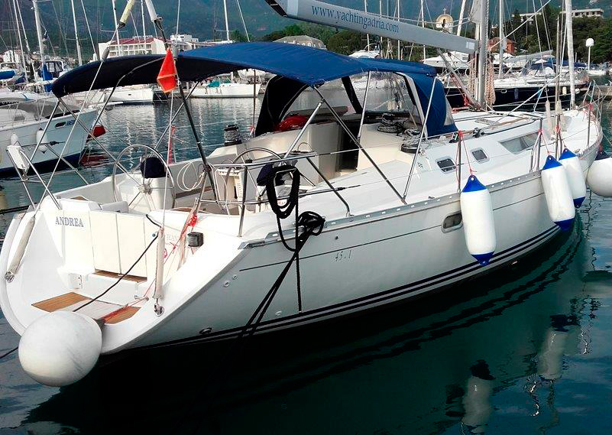

Deck equipment  electric windlass, bimini top, sprayhood, deck shower, swimming ladder, teak cockpit, cockpit table, cockpit speakers | Safety equipment  life jackets, life raft, 1 horseshoe life buoys, radar reflector, distress flare box, first aid kit, fire extinguisher, fog horn, safety harness
Navigational equipment  VHF, Tri data, auto pilot, GPS plotter (inside + in cockpit), sea charts and pilot book | Other equipment  refrigerator, stove with oven, CD/MP3, power inverter
